FPL Assistant Android Application

User Manual

Download/Install

The app is currently not available on the app store as it is still in early development and legal issues still have to be addressed within the app. A video demo can found here:

Start up

After instillation the app should appear on you android device. To start the application just click to icon. This should then start a splash screen animation. Before giving access to the app features

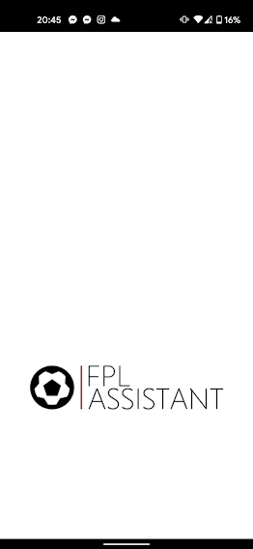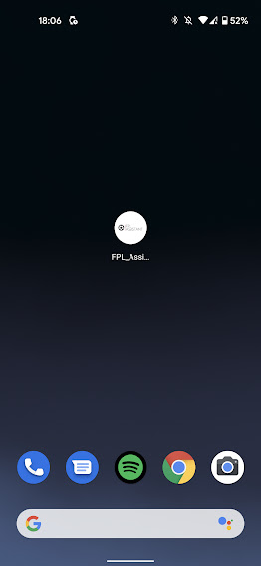

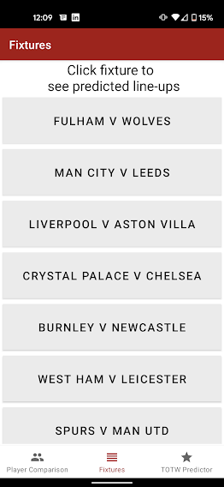Fixtures

The fixtures screen is the first screen to be displayed after the splash screen when starting the application. This screen shows the fixtures for the upcoming week of English Premier League football. You have the ability to scroll up and down to see all fixtures which will take place that week.

Each fixture can be clicked to see the predicted line-ups for that fixture. For example if ‘Fulham v Wolves; is selected the predicted line-ups screen is loaded (this can be seen in the predicted line-ups page of the manual)

The nav bar at the bottom allows for navigation between the three main pages: Player comparison, Fixtures and TOTW (team of the week) Predictor.

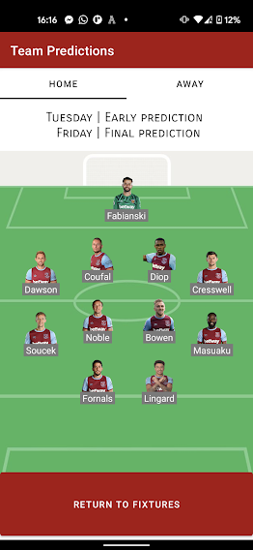Predicted line-ups

The first screen to be seen when clicking on a fixture from the fixture screen can be seen to the right. The screen shows the predicted line-up of the home team of the fixture, West Ham in this example. This is updated every Tuesday for an early prediction and Friday for a final prediction. The buttons ‘home’ and ‘away’ can be pressed to switch between the home and away team predictions. Alternatively you can swipe left and right to change between them.

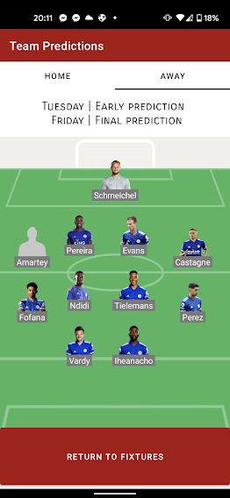The away tab can be seen to the right and is showing the Leicester City team in this example. In this example it shows if there is no image for the player or there is an error retrieving it a default placeholder is used instead.

The button ‘return to fixtures’ at the bottom of the screen will make the application return to the fixtures tab from where the fixture was pressed.

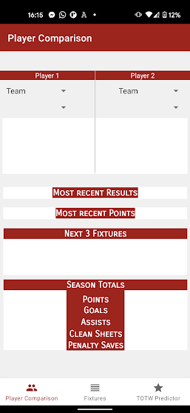Player comparison

The purpose of the player comparison screen is to compare the stats of any two players. First select the team from the first drop down ‘team’. Once a team is selected the second drop-down below it fills up with the players of that team. A player can then be selected to see their stats.

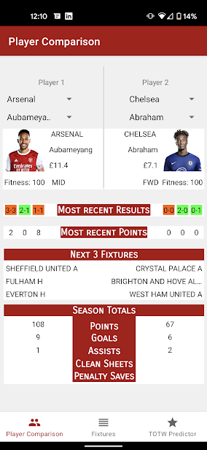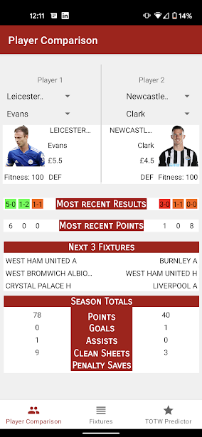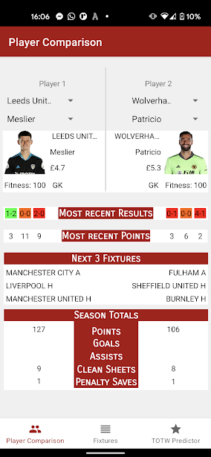Comparing GK example Comparing DEF example Comparing Mid and FWD example

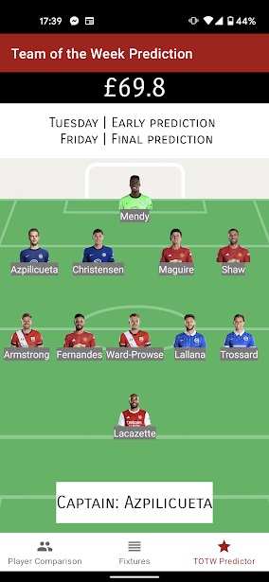Team of the week

The TOTW screen shows the eleven players predicted to get the highest score for the upcoming week. The price of the team is shown at the top of the screen followed by an explanation of when the team is updated. At the bottom of the screen a captain is picked for the team.